**SIMULATION STUDY OF MST RADAR OPERATION**

**A SUMMER INTERN PROJECT REPORT**

***Submitted by***

**KATAKAM MUNEESWARAIAH**

**Reg No: EPSS791**

***in partial fulfilment of the summer internship***

***in***



**Indian Academy of Sciences, Bangalore**

**Guide : Dr.T.V.C.Sarma Sci/Engr SF, National Atmospheric Research Laboratory, Gadanki 517112 AP**

**29/04/2013 to 19/07/2013**

**Acknowledgement**

I sincerely heartily want to express my profound gratitude to Dr.T.V.C.Sarma Sci/Engr SF, National Atmospheric Research Laboratory, Gadanki (who developed the application of RASS(Radio Acoustic Sound System) in MST Radar) for his valuable suggestions and lectures not only to complete my summer internship project but also for my career and I always indebted to him. I would like to express my sincere and heart full thank to my mother and sister, who always encourage me in all things. I would like to thank to the Indian Academy of Sciences, Bangalore for the support and funding provided under the Summer Research Fellowship Programme (SRFP)-2013. I would like to thank to the Director Prof. A. Jayaraman for giving me opportunity to complete my project at NARL, Gadanki. I would like to say thank to Administrative Officer of NARL who helped to me indirectly by giving me accommodation at NARL Guest House. I would like to express my sincere thanks to Prof.R.V.Raja Kumar Vice Chancellor of the RGUKT. I sincerely thank to Sri.B.V.Sudharkar Reddy, lecturer and Head of department of Electronics and Communications of RGUKT, R.K.Valley, who given his valuable suggestions and support for doing my project. I would like to thank to Sri.B.Srikanth lecturer in RGUKT, R.K.valley for being given suggestions from starting to ending of my project. I would like to say my special thanks to the authorities and persons who directly and indirectly given helped to me to complete my project. Finally, I would like to express my sincere thanks to all my friends who helped to me to complete this summer internship project.

**Abstract**

The purpose of this project is to study the data processing techniques of the MST Radar. There is brief explanation about MST Radar system and its working process.

In MST Radar, we transmitted wave by the transmitter, which is back scattered from the irregularities of the radio refractive indexes of the atmosphere toward the radar and it is received by the same antenna in the case of mono static system by using duplexer. Duplexer is a device which switches the operation of transmission and reception. The duplexer uses PIN-diodes for this switching operation. After receiving the echo, it pass through the RF Amplifier for amplification. The RF signal is passed through the mixing operation, where it is mixed with coherent local signal and down converted to an intermediate frequency signal. Then the signal passed through the process of quadrature detection, where one obtains the in phase and quadrature phase components. It is done by passing signal through the Low Pass Filter with bandwidth of base band signal. The In-phase and Quadrature phase outputs of the radar receiver are digitised and passed through a matched filter. The matched filter maximized the peak signal to noise power ratio or gain.

Then the ranging of the signal samples will be done. And it is coherently integrated over several inter pulse periods within the range of coherence time period in order to increase the signal-to-noise ratio. Coherent integration also reduces the data throughput. Then the signal is Fourier transformed into Doppler Spectra and power spectrum is computed. Then we done the spectrum cleaning by removing the clutter noise. Then we estimate the noise level in the signal and subtract it from the power spectrum to obtain the signal portion. The resultant is finally subjected to spectral moment estimation from which we obtain the spectral parameters such as the signal power, mean Doppler shift and spectral width. From these parameters, the three components u, v, w of the wind velocity will be obtained. So, finally we compute the wind speed and direction at particular height.

**Table Of Contents:**

**Acknowledgement ii**

**Abstract iii**

**List of Figures vi**

**List of Tables vi**

**Chapter 1. Introduction 1**

* 1. **Structure of the atmosphere 1**
  2. **Atmospheric probing technique 2**

1. **In-Situ or direct techniques 2**
2. **Remote-sensing techniques 3**
3. **Active remote sensing 3**
4. **Passive remote sensing 3**

**Chapter 2. Atmospheric Radar 4**

1. **Atmospheric Radar principle 4**
2. **Refractive index 4**
3. **Effect of the fluctuations of the refractive**

**index on echo power 5**

**Chapter 3. MST Radar and its Architecture 6**

1. **Overview 6**
2. **Architecture of the MST Radar 7**
   * 1. **Transmitter system 7**
     2. **Antenna system and feedback 8**
     3. **Receiver System 8**
     4. **Radar Controller 8**

**Chapter 4. MST Radar signal and data processing**

**on simulated and observed spectra 9**

1. **Data Processing Techniques in MST Radar 9**
2. **Sampling or Ranging 9**
3. **Coherent Integration or Time Domain Averaging 9**
4. **Spectrum Computing and Analysis 9**
5. **Incoherent Integration and Detectability 10**
6. **Spectrum Cleaning or Clutter Removal 11**
7. **Spectrum Smoothing by Moving Average technique 12**
8. **Estimation of the Noise Level 12**
9. **Spectral Moments Estimation 13**
10. **Computing UVW Components of the Wind Velocity 14**
11. **Algorithms and Results of the Simulated and Observed Spectra 15**
12. **Algorithms 15**
    * + 1. **Reading of the Data File 15**
        2. **Coherent Integration 15**
        3. **Spectrum Computing 16**
        4. **Incoherent Integration 16**
        5. **Clutter Removal Process 16**
        6. **Spectrum Smoothing by Moving Average 16**
        7. **Noise level Estimation 17**
        8. **Spectral Moment Estimation 17**
        9. **Computing UVW components of the wind velocity 17**
13. **Algorithm for the simulated and observed spectra 18**
    * 1. **Algorithm for the simulated spectra 18**
      2. **Algorithm for the observed spectra 19**
14. **Results 19**
    * 1. **Simulated and computed signal to noise ratio 19**
      2. **Signal to noise ratio Vs Doppler shift 20**
      3. **Power spectrums with Doppler shift of the MST**

**Radar Data 20**

* + 1. **U, V, W Components of the Wind Velocity 22**
    2. **Comparison of MST Radar data with the radiosonde data 23**

**Chapter 5. Conclusion 24**

**References 25**

**List of Figures :**

**Figure 1.1 :** The variation of the temperature with altitude(http://www.theozonehole.com/ images/atmprofile.jpg). 1

**Figure 3.1 :** Block diagram of the Indian MST Radar (Rao et al., 1995). 7

**Figure 4.1 :** Coherent Integration with order 20 10

**Figure 4.2 :** The signal spectrum with noise level. 10

**Figure 4.3 :** (a)Spectrum of the signal without incoherent integration, (b) Spectrum after incoherent integration (N=4). 11

**Figure 4.4 :** (a) Signal spectrum without smoothing , (b)Signal spectrum with smoothing by the 3-point moving average 12

**Figure 4.5 :** (a).Spectrum with noise level, (b).Spectrum with removal of noise level 13

**Figure 4.6 :** (a)Doppler Beam Swinging Technique, (b) Projection of the radial velocities 14

**Figure 4.7 :** Comparison of actual and computed signal to noise ratio. 19

**Figure 4.8 :** Signal to noise ratio Vs Doppler shift 20

**Figure 4.9 :** Doppler shift in east beam 20

**Figure 4.10 :** Doppler shift in west beam 20

**Figure 4.12 :** Doppler shift in Zenith Y beam 21

**Figure 4.13 :** Doppler shift in North beam 21

**Figure 4.14 :** Doppler shift in South Beam 21

**Figure 4.15 :** U(Vx) component of the wind velocity 22

**Figure 4.16 :** V(Vy) component of the wind velocity 22

**Figure 4.17 :** W(Vz) component of the wind velocity 22

**Figure 4.18 :** Comparison of U-component of MST Radar data and Radiosonde data 23

**Figure 4.19 :** Comparison of V-component of MST Radar data and Radiosonde data 23

**List of Tables :**

**Table 3.1 :**Specifications of the MST Radar System 7

**Introduction**

**1.1.The structure of the Atmosphere :**

The atmosphere is the gaseous envelope around the earth. It is like a ocean of air, under which the humans, animals and all things that are living. The extent of the atmosphere from the ground is about 1000 Km. After that there is only space. The atmosphere consists of many gaseous components in different ratios. Nitrogen, Oxygen, Argon and with small amounts of carbon-di-oxide are the major constituents of the atmosphere. The earth and its atmosphere absorbs the solar radiation, by which all the activities drives. The whole gaseous envelope undergoes changes due to the solar and anthropogenic forcing and is governed by the laws of thermodynamics and fluid dynamics.

There are four parameters that define the state of the atmosphere are the Pressure, Temperature, Humidity and Wind (Speed and Direction). Among all, the temperature is the dynamical force that varies much due to the solar radiation on the earth's atmosphere and it drives the changes in the other three parameters also. Therefore by the atmospheric temperature, the whole atmosphere can be studied. Based on this the atmosphere is divided into four regions. Those are Troposphere, Stratosphere, Mesosphere, Thermosphere. 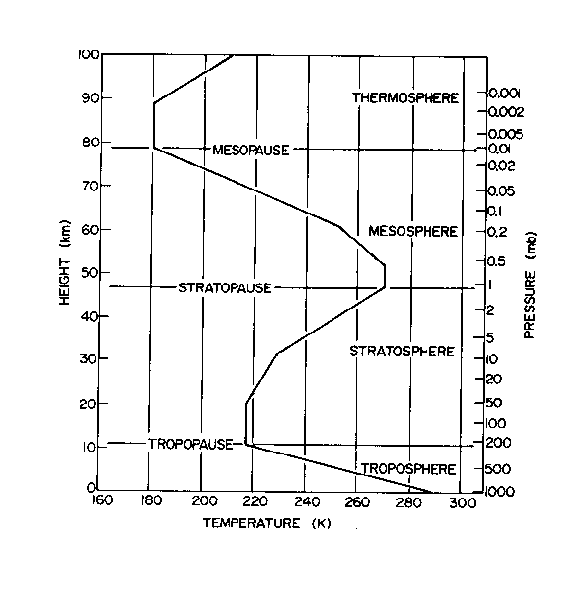

Figure 1.1 : The variation of the temperature with altitude(http://www.theozonehole.com/ images/atmprofile.jpg).

Troposphere is extent up to 10-20Km from the ground depending in the latitude. It extends more at equator and less at poles. The troposphere is mainly heated by the convective and radiative heating from the earth surface. In this region the temperature decreases as altitude increases. The region above the troposphere is called Stratosphere. It extends up to 12-50 Km from the tropopause. The major constituents of this layer are molecular nitrogen and oxygen and a number of minor chemical species that result from photochemical reactions in the ultraviolet radiation environment. So, here the temperature is due to radiation process. The temperature increases as altitude increases. The region above the stratosphere is called Mesosphere, which extends up to 100km. The density of the mesosphere layer is about 1g/cm-3. Due to this low density and resultant large mean free path, there is less ionisation. The temperature decreases as altitude increases. Above this mesosphere lies the Thermosphere. In thermosphere, the temperature keep on rising to about 10000K at an altitude of 300km. Among all these regions the lowest region which the troposphere is the layer where most of the world's weather takes place. So, to study the phenomena of the atmosphere ,there are some probing techniques.

**1.2.Atmospheric Probing Techniques :**

Observation of atmospheric parameters of Pressure, Temperature, Humidity and Wind is carried out using measuring instruments that exploit the effect of these parameters on observable or measureable physical phenomena. The simplest example is the wind cone found in airports. With this instrument the direction of the wind is directly observable with the naked eye. For scientific studies, continuous and precise readings with a high time resolution are required. In order to make such measurements, there are instruments, which are broadly divided into two categories : in-situ and remote measuring instruments.

**1.2.1.In-situ or Direct Techniques :**

**In the place**(in-situ) measurement use the direct effect of the target parameter on the instrument. The in-situ measuring instruments presently used in atmospheric studies are the disdrometer, automatic weather station(AWS), rain gauge and the radiosonde.

GPS Radiosonde is an instrument that carries sensors for temperature, pressure and humidity. In addition a GPS receiver provides position coordinates of latitude, longitude and altitude. It is flown tied to an extensible latex rubber balloon. An onboard radio transmitter continuously transmits the values of P, T, U, altitude, latitude, longitude. Using the data of altitude, latitude, longitude and the time elapsed between two successive readings, wind speed and direction is computed assuming that the displacement of balloon is reflected in the displacement of the radiosonde. It is the standard in situ technique for these four parameters and is flown from about 840 worldwide twice a day in a coordinated fashion to generate data for numerical weather prediction.

The in situ measurements although reasonably accurate lack the temporal and/or spatial continuity needed for many applications. The ideal system would be ground-based and operate continuously to provide reliable, accurate height profiles of atmospheric parameters.

**1.2.2. Remote - Sensing Technique :**

It is the process of acquisition of the data from the object or phenomenon or area without having any physical contact with them. A remote measurement usually uses light, radio waves, or sound emitted from an object or region and landing some distance away from the instrument. One feature of remote measurements is that there are some assumptions about how the light, radio waves or sound waves and how it travels across the intervening space to the instrument. The size of the object that can be detected will be purely depend on the wave length of the wave that is transmitted.

Basically remote sensing is two types : 1) Active Remote Sensing

2) Passive Remote Sensing

**1.2.2.1 Active Remote Sensing**:

In this phenomenon, the energy source should be needed in order to emit an energy waves. And it uses the sensors to detect the reflected or back scattered signals from the target. Examples of this type are RADAR (Radio Detecting And Ranging) and LIDAR (Light Detecting And Ranging). These are the tools for the remote sensing technique.

**1.2.2.2.Passive Remote Sensing:**

In this phenomenon that rely on the optical or radio emissions from the target and use the signal strength and other known characteristics of the behaviour of the atmospheric properties. So, there is no need of the source for emission of the energy, because it using the natural emission from the targets.

**Atmospheric Radar**

Radar is a tool for the remote sensing technique. The term RADAR was apparently coined by U.S.Navy in 1941. The Radar expansion is **Radio Detection and Ranging**. It uses radio waves to investigate properties of the targets.

**2.1.Atmospheric Radar Principle :**

It uses the principle of back scattering mechanism. The conventional radars obtain backscatter from the hard targets. Hard targets are characterised by the localisation in space, strong reflection coefficients due to use of metallic or high dielectric constant materials. The target of interest for the Atmospheric radars, in contrast is the clear air echoes without ionisation. The primary mechanism of backscatter from the clear atmosphere is the radio refractive index fluctuation experienced by an electromagnetic wave due to the presence of localised scattering centres known as refractive index irregularities that are flowing in the background mean flow.

**2.2. Refractive index :**

The radio refractive index of the atmosphere n is given by the following relation.

(2.1)

where p is the absolute pressure in hPa, pv is the partial pressure of the water vapour in hPa, T is the absolute temperature, Ne is the number density of electrons, and for a frequency , is the critical plasma density. The first term dominates in the lower atmosphere where the water vapour is large. As is well known, the water molecule has a dipole moment, which varies with frequency. At extremely high frequency of visible light, only the polarized electric field of the water molecules counts for the refractivity. Above the tropopause height, the partial pressure of the water vapour becomes negligibly small. The second term partial pressure due to dry air is of primary importance in the free troposphere, stratosphere and lower mesosphere. Unlike the first term, this term is frequency independent. The third term is dominate in the ionosphere, where the electron density increases rapidly with height.

**2.2.1. Effect of the fluctuations of the refractive index on echo power :**

In the absence of the total reflection, scattering from fluctuations in the refractive index n dominates the received echo of the atmospheric radar. In ionosphere statistical fluctuations of the electron density due to random thermal motion of electrons and ions can be strong enough to cause detectable scattering. This scattering is called incoherent scattering because scattered wave form individual electrons are random in phase, so that they add up incoherently. Then the received echo power is proportional to the number of electrons illuminated by the radar.

Fluctuations due to atmospheric turbulence is the major source of scattering in the lower and the middle atmosphere. This scattering is called the coherent scattering. The main difference of the coherent scattering from the incoherent scattering is that the fluctuation of n is caused by the macroscopic motion of air parcels, each of which contains a large no of the molecules and/or electrons. In this case the scattered echo power is roughly proportional to the square of the number density of the scatterers. This enhancement in the echo power is the basis for the MST radars being able to observe the neutral atmosphere with a relatively small system compared to powerful incoherent scatter radars.

The large difference in the atmosphere from the other targets is that having distributed nature. So, there is equations for the received echo power for different types of targets.

**MST Radar and its Architecture**

**3.1.Overview :**

**MST Radar at Gadanki :**

A Mesosphere, Stratosphere, Troposphere (MST) Radar was constructed at Gadanki (13.50N, 79.20E) in south eastern part of India. The radar construction was done in two phases (ST mode and MST mode) and was completed by 1993. It is a VHF pulse-coded, coherent, phased array Doppler radar working at 53 MHz frequency with a peak power of 2.5 MW. The main specifications of the system is displayed in the Table 3.1. and the system block diagram is shown in Figure 3.1.

|  |  |
| --- | --- |
| **Table 3.1 :**Specifications of the MST Radar System | |
| **Aspect** | **Specification** |
| Location | Gadanki(13.5N, 79.2 E) |
| Operating Frequency | 53 MHz |
| Wave Length | 5.66 m |
| Peak Power Aperture Product | 7108 w-m2 |
| Peak Power | 2.5MW |
| Spatial Resolution Range | 150 m(pulse width) |
| Maximum Duty Ratio | 2.5% |
| Velocity Resolution | 0.1 m/sec |
| Time resolution | 0.5 min |
| Antenna | Phased array with 1024 Yagi-Uda antennas |
| No of range bins | Up to 256 |
| Pulse width | 1-32 µs |
| Pulse Repetition Frequency | Maximum 8KHz |
| Beam width | 30 |
| Maximum of FFT Points | User defined; Maximum 512(for online processing) |
| Data Acquisition | Two channel PCI-card based data acquisition system with 14 bit ADCs |

MST Radar uses radio wave signals to investigate the atmospheric changes. The name itself reflecting that it observes the changes in Mesosphere, Stratosphere, Troposphere layers of the earth atmosphere. The MST Radar make use of the scattering and reflection from the variations of humidity, temperature and electron density, induced by the turbulence and fluctuations in the refractive index of the atmosphere. The MST Radar is capable of providing estimates of the atmospheric parameters with very high resolution and on a continuous basis. It can operate at anytime throughout the day. The main advantage with this is the providing continuous data.

**3.2. Architecture of the MST Radar**

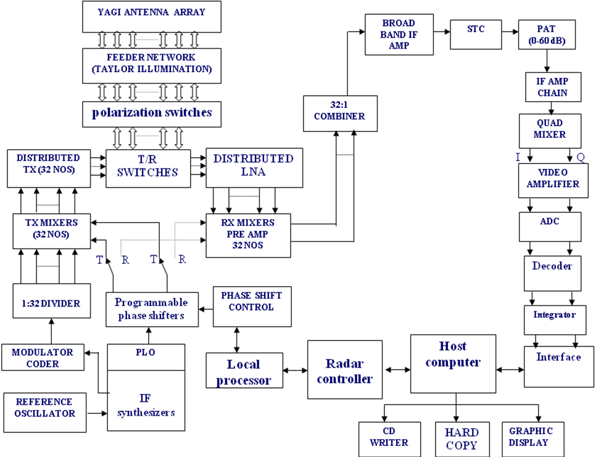

FEPU PCI Board

5 MHz

5 MHz

48 MHz

Figure 3.1 : Block diagram of the Indian MST Radar (Rao et al., 1995).

**3.2.1.Transmitter system :**

The transmitting system consists of 32 transmitters ranging from in power from 15 kW to 120 kW. And these 32 transmitters divided into six categories according to their power. The central 12 transmitters generate a peak power of 120 kW each, next peripheral two transmitters each on either side generate 90 kW, and further on two on each side generate 70 kW, 56 kW, 36 kW and 15kW respectively. The 120kW, 90 kW and 70 kW transmitters are made of four amplifier stages and associated power monitoring, control and safety interlock circuits. We have the transmitters with different levels of power for the purpose of transmitting high power to central antennas and low power to peripheral antennas in order to achieve Taylor windowing of antenna power aperture required for better antenna side lobe level.

**3.2.2.Antenna System and Feedback :**

The phased antenna array consists of two orthogonal sets of 1024 three - element Yagi-Uda antennas (shown in Figure 3.3(a)) arranged in a 32 32 matrix over an area of 130m 130 m. The two sets are arranged with pairs of Yagis mounted on the same poles. The inter element spacing in the antenna is 0.71𝜆. This gives a grating lobe-free beam scanning up to an angle of 240 from zenith(vertical). Each linear sub array of 32 antennas is illuminated by the transmitter. For side lobe reduction, tapering is done by varying the transmitted powers [Sarkar 1988]. Feeding of the output of transmitter to the antenna subarray is done by means of a vacuum rely(directional couplers) has an insertion loss of 0.1dB.

**3.2.3.Receiver System :**

The antenna array being reciprocal in nature. So, the array pattern is same as in the case of the transmit direction. The signal received from each subarray is fed into Low Noise Amplifier(LNA) of gain 24 dB after passing through a blanking switch, which provides additional attenuation to the transmitter leakage during the transmission period. The output from the LNA is down converted to IF in a mixer- preamplifier with gain of 7dB.

**3.2.4.Radar Controller :**

The control of almost all subsystems of the radar is done by a radar controller PC running the radar control software. This software is developed on the C++ platform for windows operating system. The RC software provides for programming the radar operational parameters which are pulse width, inter pulse period, beam directions, number of range bins to be recoded, start and end of heights to be sampled, number of coherent integrations, data type etc.. all data will be recorded in the file known as ESF(experiment specification file). Based on the ESF parameters, the transmitter pulse width and timing control signals for transmitter, phase shifter, duplexer and RF blanking switch are generated in the timing and control signals generator. Now, let discuss about the data processing techniques.

**MST Radar Signal and Data Processing on Simulated and Observed Spectra**

**4.1. Data Processing Techniques in MST Radar**

**4.1.1. Sampling or Ranging :**

The sampled digital signal is arranged as a function of a round-trip time from transmission to reception, which is generally called ranging. The total range is divided into range bins and the pulse can be taken from each range bin. For a mono static pulse radar, the distance or range R to the scatterer from the radar will be

(4.1)

where c is the light speed c = 3 108 m/s and TR is the time interval between the pulse transmission and detection. The interval between successive pulse transmissions is called the inter pulse period (IPP). The decision of the IPP is taken by considering the maximum unambiguous range. Otherwise there will be echoes of the before pulses in the next pulse. This is called second time around echoes.

**4.1.2. Coherent Integration :**

The detected quadrature signals are usually integrated for many pulses and made one integrated pulse in order to increase the signal to noise ratio. This signal processing is called the coherent integration. With coherent integration the total no of pulses will reduced by the factor N, if N no of coherent integrations is carried out. The integration will be done over several inter pulse periods in the case of the coherent echo. The Figure 4.1 shows the difference between the signal without coherent integration and with coherent integration with order 20.

**4.1.3. Spectrum Computing and Analysis :**

The quadrature signal components are converted from time domain to frequency domain by using Fourier transform with appropriate sampling frequency that is with Nyquist rate. From this, the power spectrum will be computed by squaring the magnitude spectrum. Further analysis will be taken from the power spectral only. Figure 4.2 shows the spectrum of the signal with noise level.

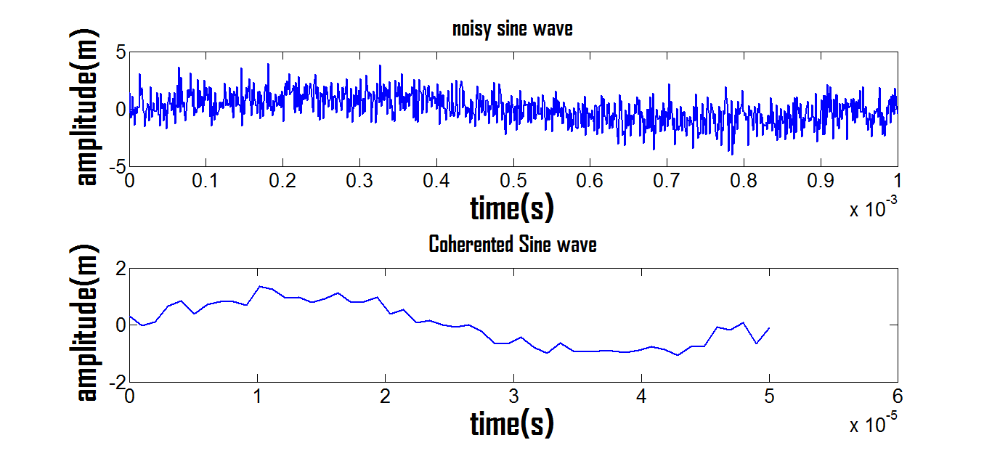

Figure 4.1 : Coherent Integration with order 20

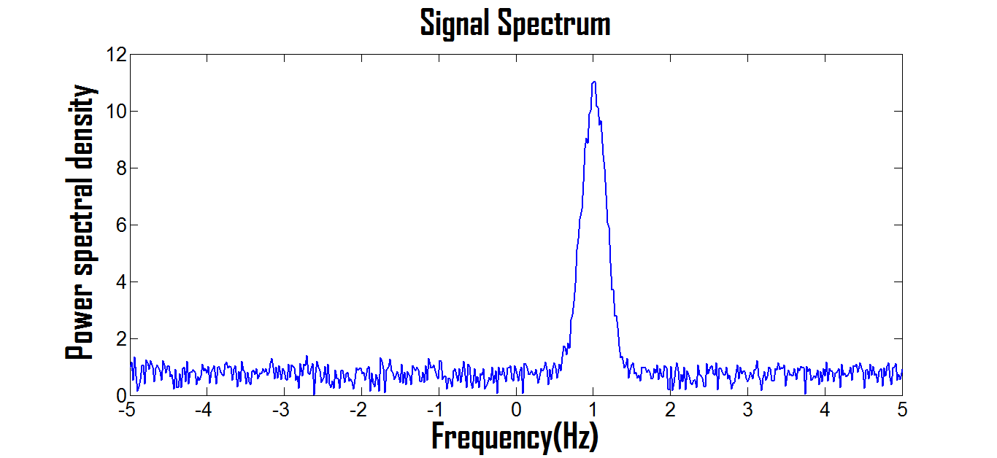

**Figure 4.2 :** The signal spectrum with noise level.

**4.1.4. Incoherent Integration and Detectability :**

The averaging of the points of the same frequency over the several spectrums is called the Incoherent Integration. It is done, in order to improve the detectability of the signal in the spectrum. The detectability of a signal can be defined as   
 (4.2)

where Ps is the peak spectral density of the spectrum and N is the standard deviation of the noise. For a single spectrum N is equal to the noise level PN. If Doppler spectra are integrated incoherently by averaging N times, the mean values of the spectral densities of signal and noise will not change. But the ratio is becomes . Due to this the detectability (D) will be increase by times. So, incoherent integration will increase the signal detectability by suppressing the noise spectral deviation. The below Figure 4.3. shows the spectrum of the signal before and after incoherent integration of order N = 4.

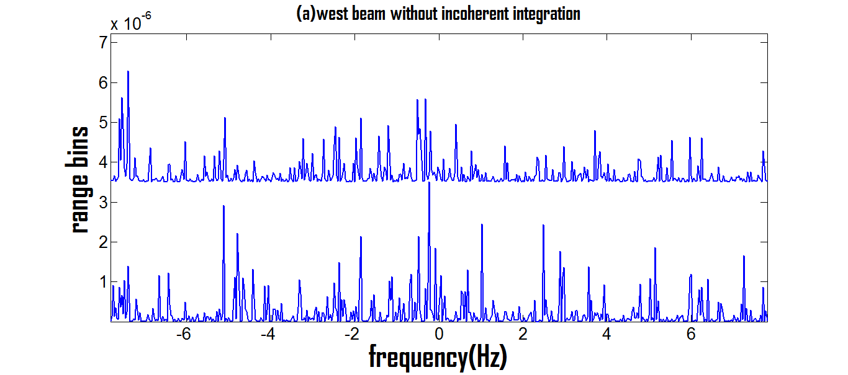

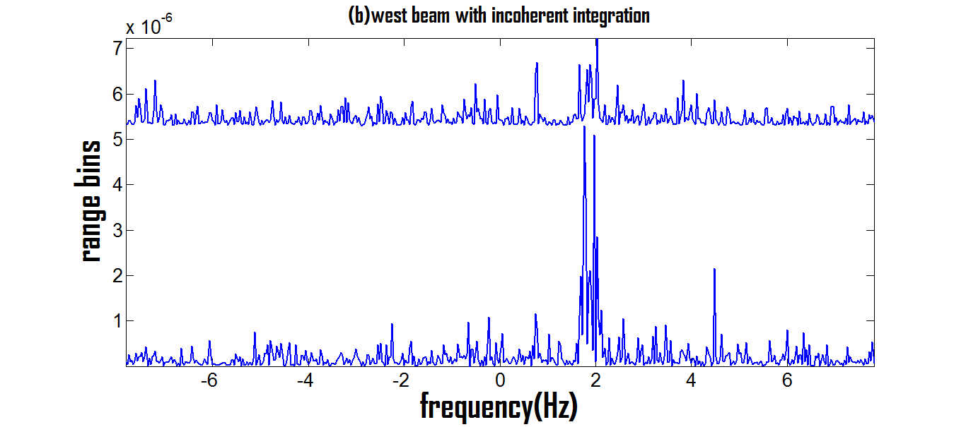

**Figure 4.3 :** (a)Spectrum of the signal without incoherent integration, (b) Spectrum after incoherent integration (N=4).

**4.1.5. Spectrum Cleaning or Clutter Removal :**

Due to various reasons the echoes of the radar may get effected by the ground clutter, system bias, interference etc. The spectrum should be clean before going to further analysis or to have signal peak detection. For example, the ground clutter signal have single spectral peak line at the origin or zero frequency. It is removed by various techniques in order to have comparable signal peak. One way is to taking average of the values of the immediately beside frequencies and replacing that value at the origin.

(4.3)

**4.1.6. Spectrum Smoothing by Moving Average Technique :**

It is a process of taking series of averages over the entire data points. The set of the moving average will be obtained by taking the average of the initial set of points of the data. Then by excluding the initial points and including the next points in the original data, the average will be computed and this repetitive process will be done for entire data and plot the graph. This is called the moving average technique. By this process, the curve will obtain smooth.

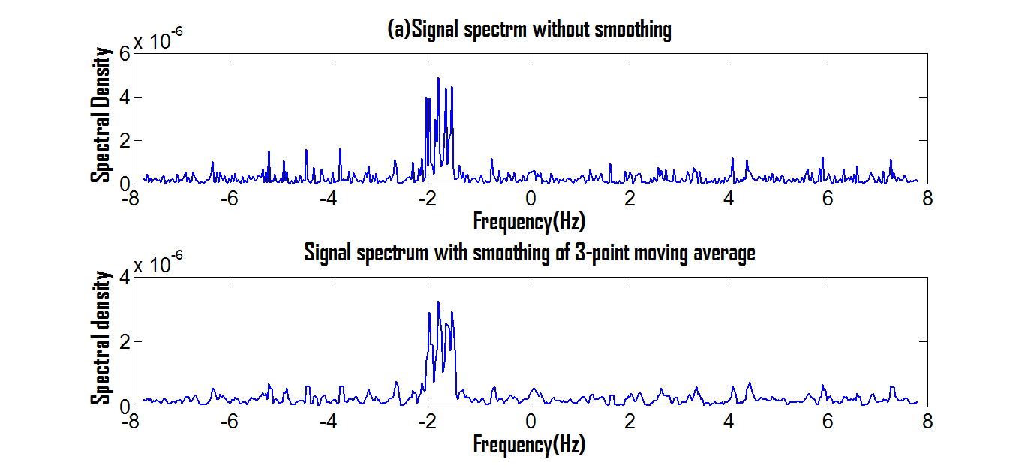

**Figure 4.4 :** (a) Signal spectrum without smoothing , (b)Signal spectrum with smoothing by the 3-point moving average

**4.1.7. Estimation of the Noise Level** **:**

The estimation of the noise in the spectrum is the called the Noise Level. There are many methods to find the noise level, but only few given near accurate value of the noise level. Peter H.Hildebrand and R.S.Sekhon are given one best method for estimating the noise in 1974.(Peter Hildebrand and R.S.Sekhon et al.,197)

From Doppler spectrum, construct the new spectrum by rejecting the spectral densities stronger than some arbitrary threshold level and checking conditions of the white noise that the spectrum is satisfying. This series of processes will be done by taking decreasing thresholds until the spectrum satisfies the conditions of the white noise. And that threshold value will be taken. The following steps will be computed for estimating the noise

(4.4)

(4.5)

(4.6)

where N is the number of independent spectral densities, the number of lines over which a moving average is taken. For white noise the ratio Rn  should be unity.

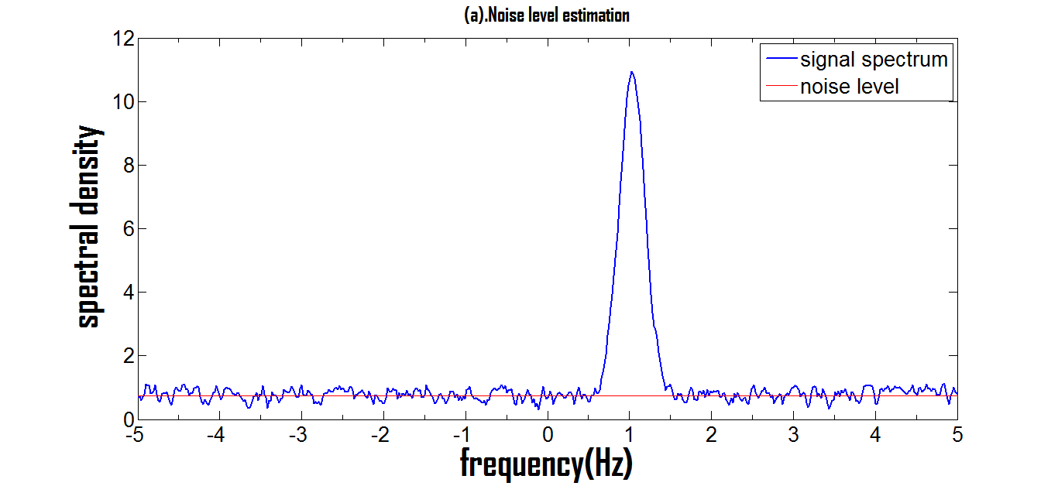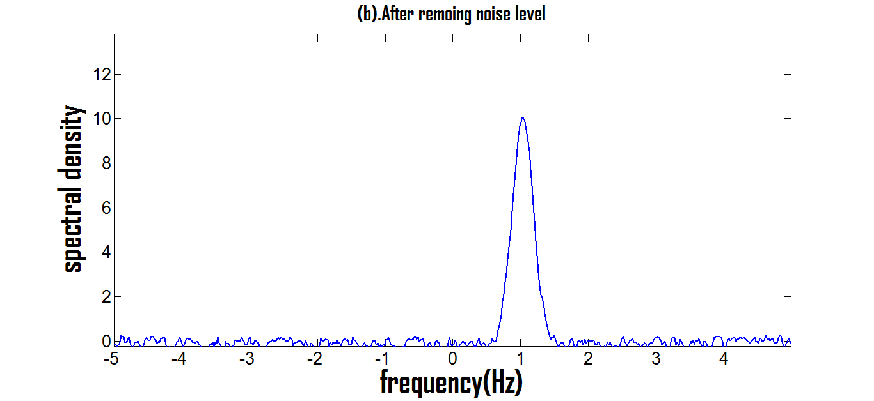

**Figure 4.5 :** (a).Spectrum with noise level, (b).Spectrum with removal of noise level

**4.1.8. Spectral Moments Estimation :**

The whole signal processing is done to extract the spectral zeroth, first and second moments and from the moments the total power , Doppler shift and spectral width will be obtained. From these the Doppler velocity will be computed.

Woodman(1985) given the basic equations for computing of three moments. Those are given below. (Ronald F. Woodman et al., 1985)

M0 = (4.7)

M1 = (4.8)

M2 = (4.9)

The Equations 4.7 -4.9 represents the total power, Doppler shift and spectral width of the signal respectively. These are always well defined, even in the case of deviations from the assumptions that have taken.

**4.1.9. Computing UVW Components of the Wind Velocity :**

The main motto of the Radar is to obtain the u, v, w components of the wind velocity. There are different techniques to compute the three non-coplanar components of the wind velocity. From which the speed and direction of the wind can be computed.

There are two techniques for computing the wind velocity components are Doppler-Beam-Swing (DBS) method and Spaced-Antenna-Drifts method. (ref:[7])

VR2 w VR1

w

w

VR

u

θ

θ θ

**Figure 4.6 :** (a)Doppler Beam Swinging Technique, (b) Projection of the radial velocities

The DBS method makes use of multiple antenna beams each of oriented in different directions to compute the line-of-sight velocities or radial velocities in that beam direction. For computing the velocity components at least three different beam orientations (Vertical, East-West, North-South) should be required. By projecting the velocities of these three beams on the vertical beam, the three components of the wind vector can be computed. Let consider that VR1, V R2 ,V R3 and V R4, VR5 are the radial velocities along east, west, north, south and vertical directions respectively and u, v, w are velocity components along east-west direction, north-south direction and vertical wind components.

Then the components of the wind can calculated from above Figure 4.6. as

(4.10)

(4.11)

(4.12)

In the same way, v can be computed at north-south direction

(4.13)

(4.14)

(4.15)

(4.16)

The three dimensional winds are determined from the Doppler shift() induced in each beams. Here, the assumption is taken that the wind field is horizontally uniform across distances separating the sampling volumes along the beams. So, by this technique, we can study the atmosphere by finding wind velocity components.

**4.2. Algorithms and Results of the Simulated and Observed Spectra :**

**4.2.1. Algorithms :**

|  |  |
| --- | --- |
| **4.2.1.1. Reading of the Data File :** | **4.2.1.2. Coherent Integration :** |

|  |  |
| --- | --- |
| **4.2.1.3.Spectrum computing :** | **4.2.1.4. Incoherent Integration :** |
| **4.2.1.5. Clutter Removal Process :**  Formula : | **4.2.1.6. Spectrum Smoothing :** |

**4.2.1.7.Noise Level Estimation :**



|  |  |
| --- | --- |
| **4.2.1.8. Spectral Moment Estimation :** | **4.2.1.9. Computing UVW components :** |

**4.3.Algorithm for the simulated and observed spectra :**

**4.3.1.Algorithm for the simulated spectra :**

Comparing the actual and computed signal to noise ratio of the signal.



**4.3.2. Algorithm for the observed spectra(data processing of the MST Radar) :**



**4.4.Results :**

**4.4.1. Simulated and computed signal to noise ratio :**



**Figure 4.7 :** Comparison of actual and computed signal to noise ratio.

**4.4.2. Signal to noise ratio Vs Doppler shift :**

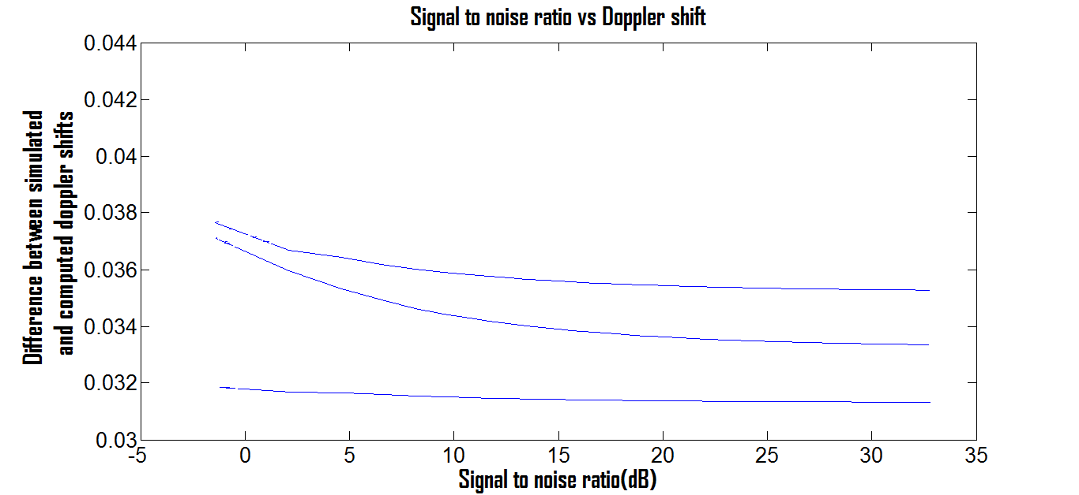

**Figure 4.8 :** Signal to noise ratio Vs Doppler shift

**4.4.3.Power spectrums with Doppler shift of the MST Radar Data of 03/12/2007 at 5:24:50PM:** 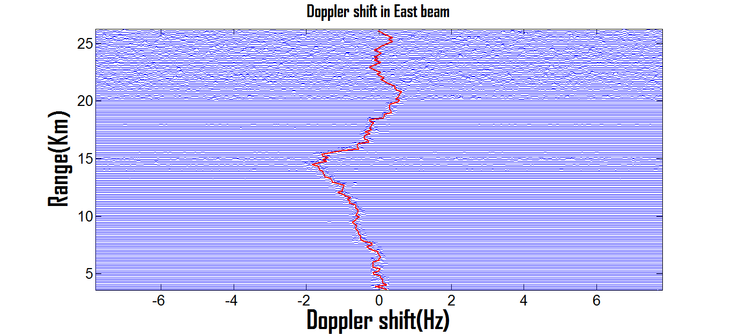

**Figure 4.9 :** Doppler shift in east beam

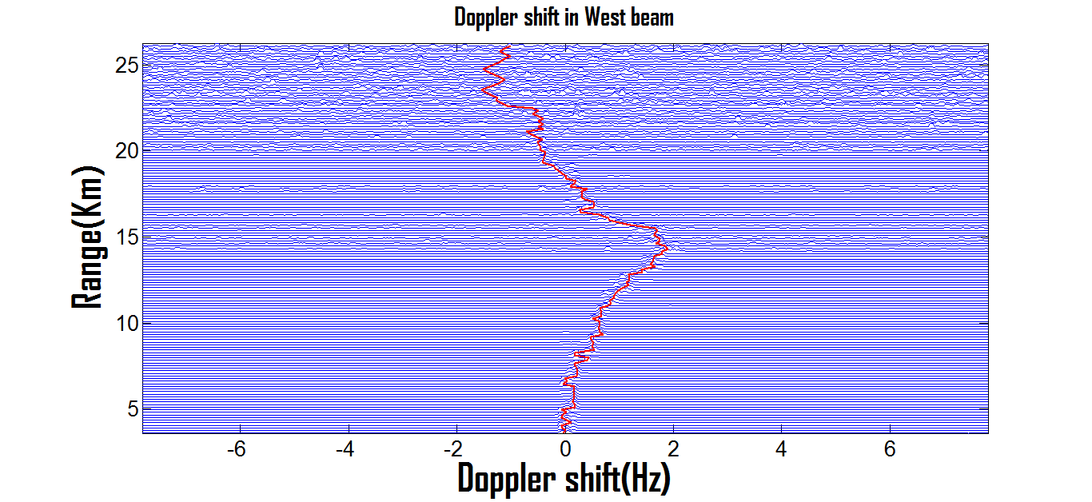

**Figure 4.10 :** Doppler shift in west beam

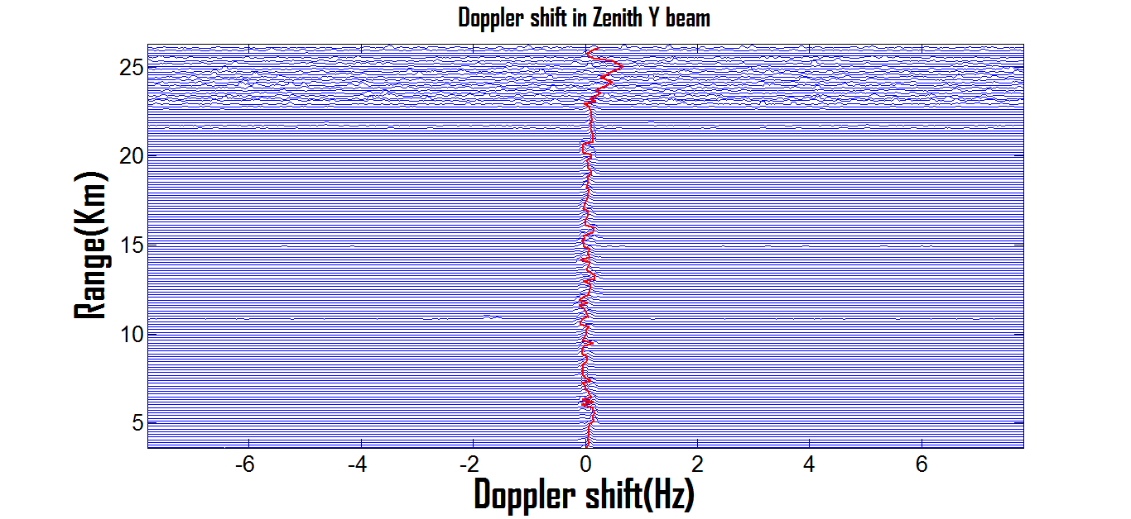

**Figure 4.12 :** Doppler shift in Zenith Y beam

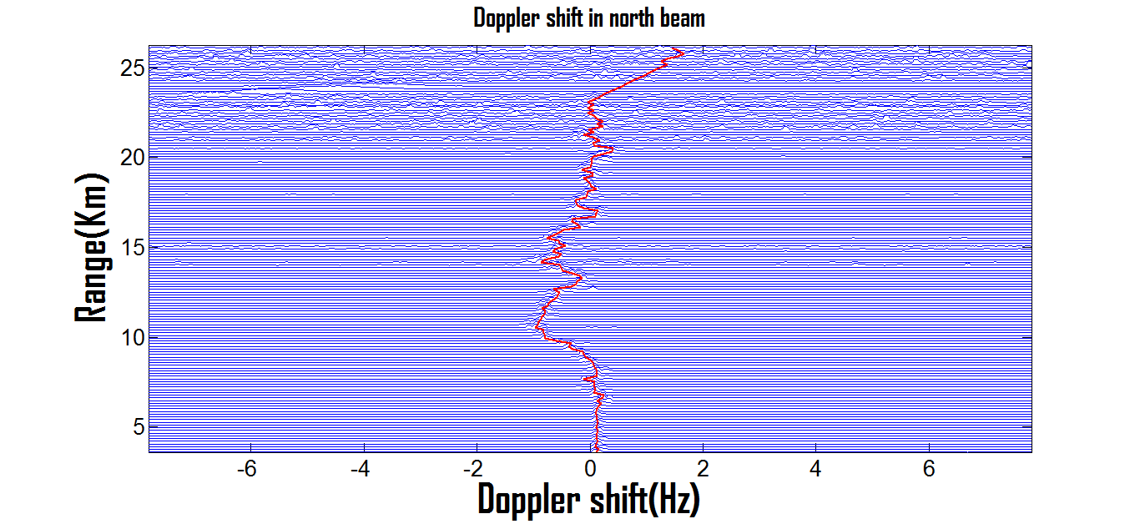**Figure 4.13 :** Doppler shift in North beam

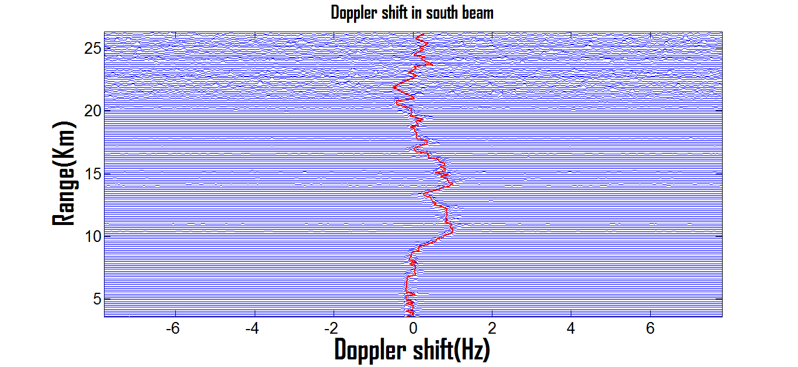

**Figure 4.14 :** Doppler shift in South Beam

**4.4.4. U, V, W Components of the Wind Velocity :**

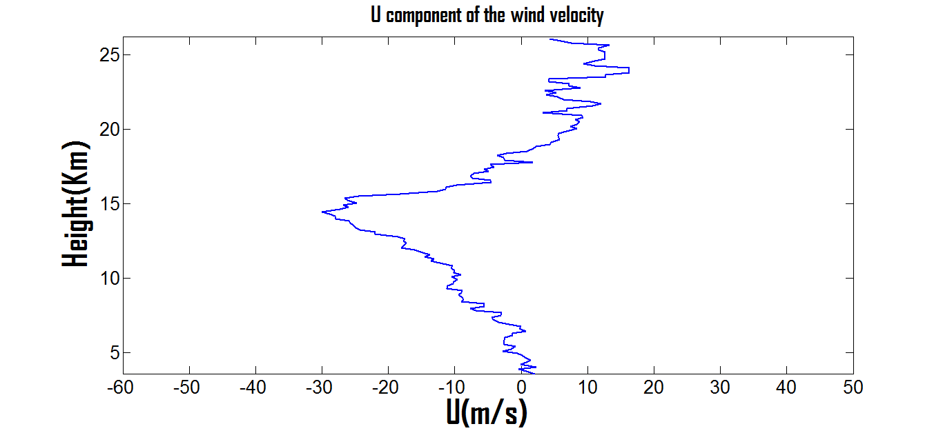

**Figure 4.15 :** U(Vx) component of the wind velocity

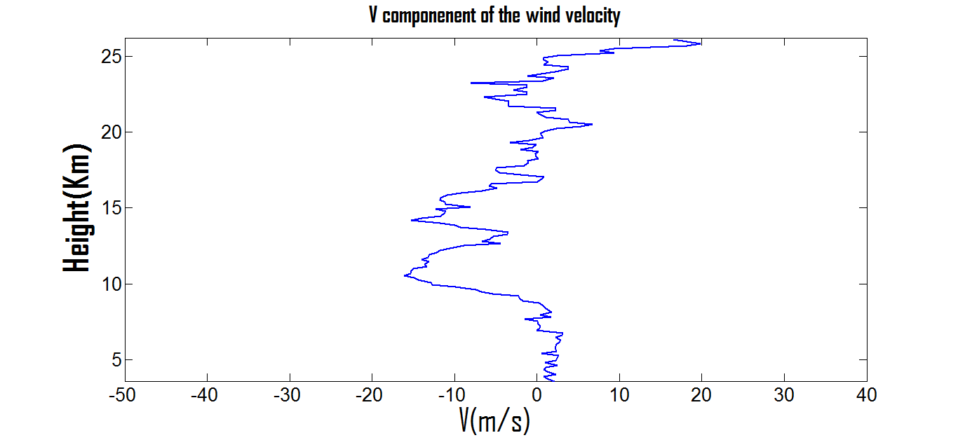

**Figure 4.16 :** V(Vy) component of the wind velocity

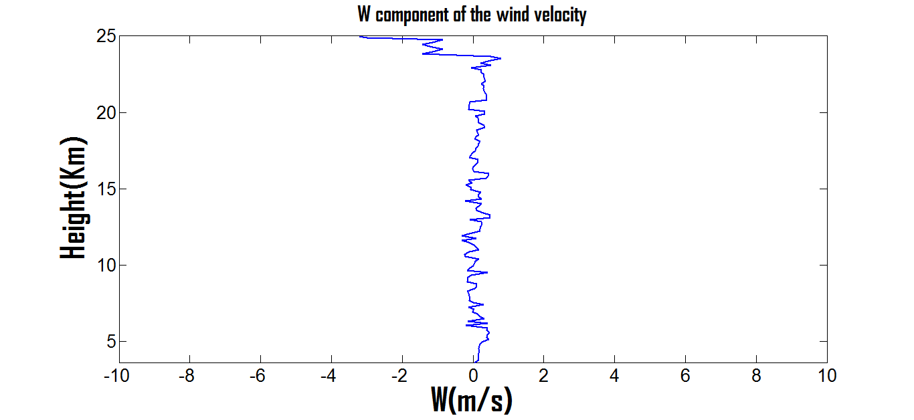

**Figure 4.17 :** W(Vz) component of the wind velocity

**4.4.5. Comparison of MST Radar data with the radiosonde data :**

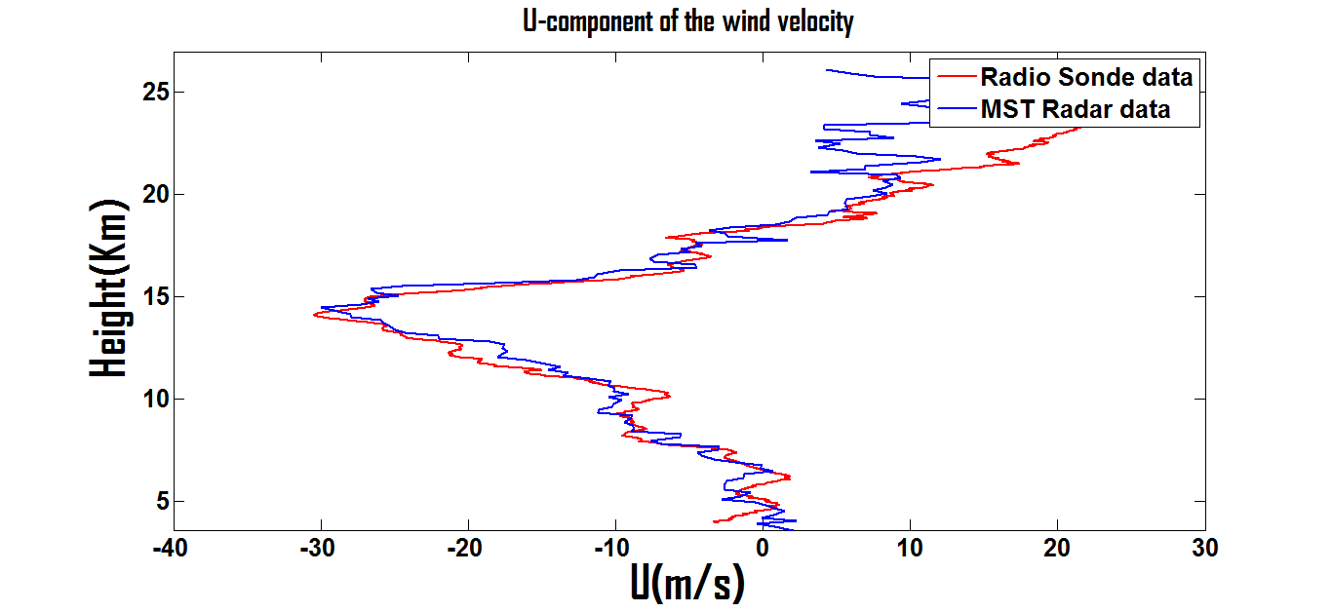

**Figure 4.18 :** Comparison of U-component of MST Radar data and Radiosonde data

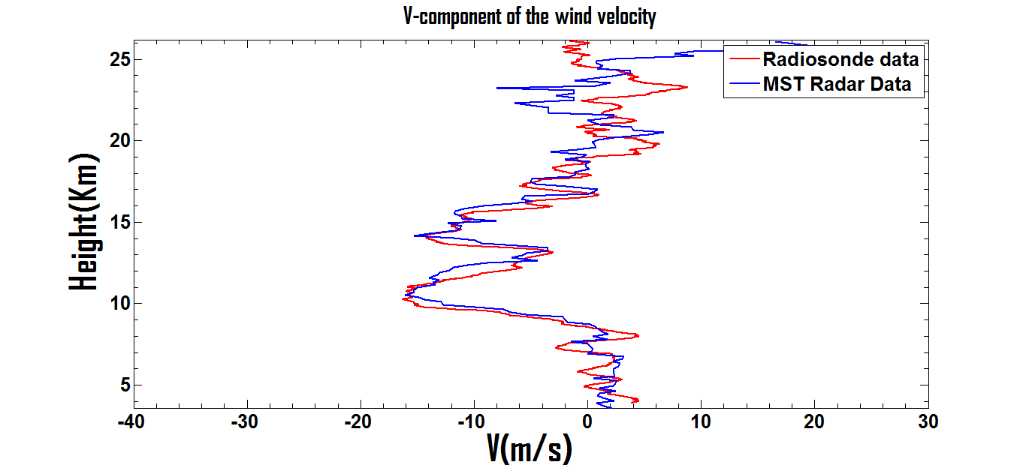

**Figure 4.19 :** Comparison of V-component of MST Radar data and Radiosonde data

From above Figures 4.18 and 4.19 , the wind velocity components obtained from both MST Radar data and Radiosonde data are almost same. But the MST Radar data is continuous and the Radiosonde data is in-situ measurement data.

**Conclusion**

In this report, first there is an overview about the atmosphere and its composition of gases is outlined. Then the basic layers of the atmosphere around the earth is explained in detailed. Due to the temperature variations in these layers, the parameters like Humidity, Pressure and Wind(speed and direction) will be changes. The atmospheric probing techniques like in-situ and remote measurements are described.

In chapter 2, brief explanation about the atmospheric radar and the effect the fluctuations in the refractive index on echo power is discussed. The MST Radar at Gadanki and its specifications and functional blocks are briefly outlined in chapter 3. The data processing techniques on the simulated and MST radar Observed spectra are carried in chapter 4. There are sequence of techniques for the data processing of the signal obtained from the MST radar for the purpose of analyses of the signal characteristics. In the case of simulated spectra (Dusan S.Zrnic et al., 1975), the difference of actual and computed Doppler shifts with respect to Signal to Noise Ratio(SNR) is compared and observed that, as SNR increasing the difference value decreasing and reaching zero for higher and higher SNRs. Means, for higher SNR the computed and actual Doppler shifts are obtained same value. So, the exact detection of the Doppler shift of the wind is possible only at higher SNRs only.In case of the MST Radar data, up to the threshold value of **-16.5 dB** of SNR, the signal peak is detected clearly. Due to the attenuation in the signal strength, one cannot justify the signal peak below the threshold value of -16.5dB. This phenomena is observed at above 26.2 Km distance away from the radar. The Doppler shift also not detected precisely above this height.

From the computation of the Doppler shifts at three non co-planar directions, the three components of the wind speed and direction will be obtained. These results has compared with the radiosonde data. By observing the Figures 4.18 and 4.19, the difference between MST Radar data and radiosonde is high at higher altitudes. In MST Radar case, the data will be received continuously at the receiver. So, (as mentioned in simulation case) due to having low signal to noise ratio at higher altitudes, the same value of the radiosonde is not obtaining in the MST Radar. So, having high signal to noise ratio, the MST Radar also gives precise values as the radiosonde.

**References**

Balsley, B.B. (1995), Development of generic radar equations for wind profiling, in Diagnostics tools in atmospheric physics, Proceedings of the international school of Physics, Enrico Fermi, Course CXXIV 22 Jun - 2 Jul., 1993, pp 69-78, IOS Press, Amsterdam.

Rao. P.B., A.R. Jain, P. Kishore, P. Balamuralidhar, S.H. Damle and G. Viswanathan (1995), Indian MST radar 1. System description and sample vector wind measurements in ST mode, Radio Science, vol. 30 , pp. 1125 - 1138.

Jurgen Rottger(1989), The Instrumental Principles of MST Radars and Incoherent Scatter Radars and The Configuration of Radar System Hardware, vol.30, pp. 54-113.

Sarkar, B.K., P.B. Tole, and A. Agarwal (1988), Feeder network for the Indian MST radar, in Handbook for MAP, edited by C.H. Liu and B. Edwards, vol.28, pp. 523-527, SCOSTEP Sect., Urbana, Illinois.

Dusan S. Zrnic ,(1975) Simulation of Weatherlike Doppler Spectra and Signals, Journal of Applied Meteorology, vol.14, pp. 619-620.

Peter H. Hildebrand and R.S. Sekhon (1974) , Objective Determination of the Noise Level in Doppler Spectra , Journal of Applied Meteorology,vol.13, pp. 808-811*.*

Ronald F. Woodman (1985), Spectral moment estimation in MST radars, Radio Science, Vol.20, pp 1185-1195.